**ADVANCED COMPUTER VISION WITH TENSORFLOW**

**MODULE 1**

**Concepts in computer vision**

Classification and object detection intro

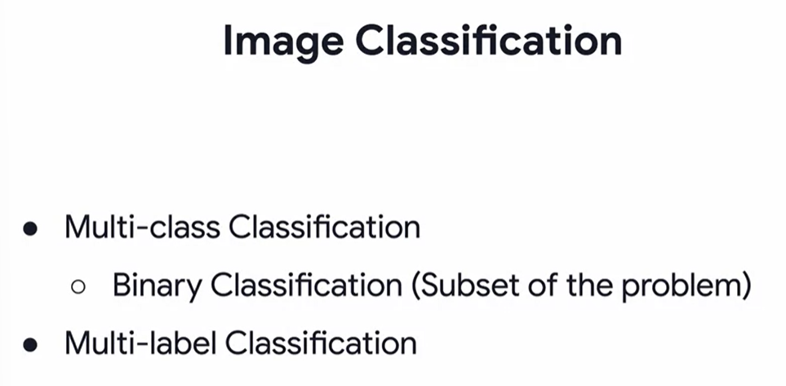

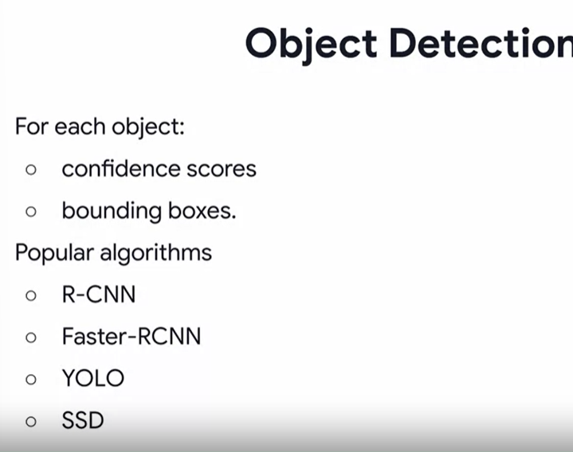

Segmentation intro

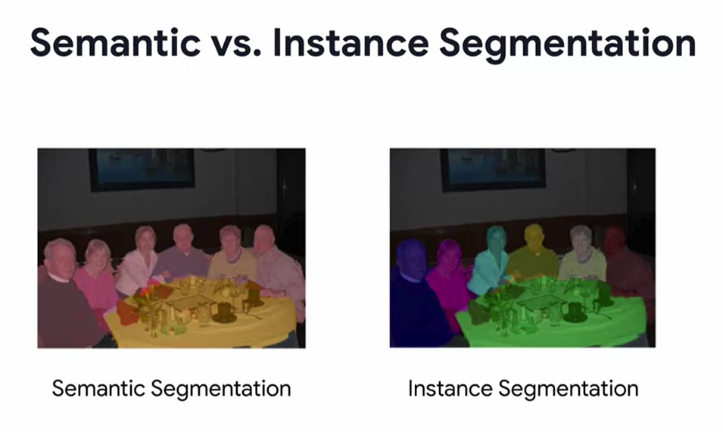

**Transfer Learning**

Why transfer learning

What is transfer learning

Options in transfer learning

**Advanced Transfer Learning**

Transfer learning with ResNet50

ResNet50 in Code

**Object Localization and Detection**

Network architecture for object localization

Evaluating object localization

**MODULE 2**

**Object Detection**

Object detection and sliding windows

References: amazon recognition, powerAI, DIGITS

R-CNN

Fast-R-CNN

Faster R-CNN

**Object detection in TensorFlow**

Getting the model from TensorFlow hub

Running the model on an Image

**Object Detection APIs**

Installation and overview of APIs

Visualiztion APIs

**Retraining with the Object detection API**

Loading a RetinaNet Model

Loading Weights

Data Prep and Training Overview

Custom Training Loop COe

**MODULE 3**

**Image Segmentation Overview**

**Popular image segmenatation architectures**

**MODULE 4**